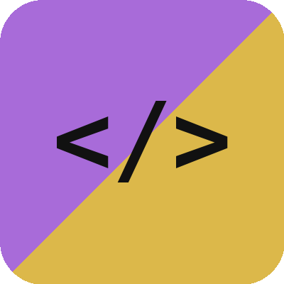
CAYO CODING CO.
Website Design & Development Agreement

This agreement is between Cayo Coding Co. (“Developer”) and the client named below (“Client”), and covers the website project described here.
Client / Business name: ________________________________
Project name: ________________________________
Date: ________________________________
1. Project scope
Developer will design and build a website for Client including:
- [e.g. Up to 5 pages: Home, About, Menu/Services, Gallery, Contact]
- [e.g. Mobile-responsive layout]
- [e.g. Contact form connected to Client's email]
- [e.g. Basic on-page SEO: page titles, meta descriptions]
Anything not listed above (e.g. online ordering, e-commerce, custom booking systems, copywriting, professional photography) is outside this scope and can be quoted separately.
2. Timeline
Estimated completion: [X weeks] from the date Developer receives (a) the signed agreement, (b) the deposit, and (c) all content and photos from Client. Delays in Client providing content will extend the timeline accordingly.
3. Fees & payment
Total project fee: $[Amount] BZD.
- 50% deposit ($[Amount]) due before work begins.
- Remaining 50% ($[Amount]) due upon completion, before the site is published live or final files are handed over.
Payment via [bank transfer / other method]. The deposit is non-refundable once design work has started.
4. Revisions
This project includes [2] rounds of revisions on the initial design. Additional revision rounds, or changes requested after final sign-off, are billed at $[Amount]/hour.
5. Ownership & handoff
Upon receipt of full payment, ownership of the completed website design and code transfers to Client. The domain name and hosting account will be registered in Client's name where practical; if Developer manages hosting on Client's behalf, terms are covered in Section 6.
6. Hosting & maintenance (optional)
Client may optionally continue with Developer for ongoing hosting and minor updates at $[Amount]/month, covering hosting costs, small text/content edits, and uptime monitoring. This is billed separately from the project fee above and can be cancelled by either party with 30 days' written notice. If cancelled, Developer will assist with a one-time transfer of the site to Client's own hosting account.
7. Client responsibilities
Client agrees to provide requested content (text, photos, logo, business details) in a timely manner and to respond to Developer's requests for feedback within a reasonable time, as delays on Client's part will affect the timeline in Section 2.
8. Portfolio use
Developer may display the completed project (screenshots, link, and general description) in Cayo Coding Co.'s portfolio and marketing materials, unless Client opts out in writing.
9. Termination
Either party may terminate this agreement with written notice. If terminated after work has begun, Client is responsible for payment covering work completed to date; the deposit is non-refundable in this case.
Signatures
By signing below, both parties agree to the terms above.
Developer signature: ________________________________
Date : ________________________________

Client signature: ________________________________
Date : ________________________________

